|  |
| --- |
| CS:GO Round Winner Classification |
| Global Master in Big Data & Business Analytics  Machine Learning I I  Professor: **JESUS SALVADOR RENERO QUINTERO** |
| September 24  TEAM F  Authored by: ABDULAZIZ A., ADDISON P.,  ALEKSANDAR M.,ESPERANZA M., JUAN PEDRO B. |

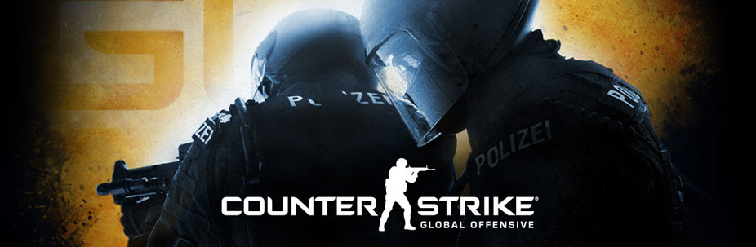

Table of Contents

Introduction 2

EXPLORATORY DATA ANALYSIS  2

Pre-processing 2

Feature engineering 3

ModelLING 3

Evaluation Metrics 4

Conclusions & Findings 5

# Introduction

Team F is assigned with binary-class classification task using a dataset taken from Kaggle. The dataset was originally published by Skybox as part of their CS:GO AI Challenge, running from Spring to Fall 2020. The dataset consists of ~700 demos from high level tournament play in 2019 and 2020. Warmup rounds and restarts have been filtered, and for the remaining live rounds a round snapshot have been recorded every 20 seconds until the round is decided. Following the initial publication, It has been pre-processed and flattened to improve readability and make it easier for algorithms to process. The total number of snapshots is 122411.

# Exploratory Data Analysis

# Pre-processing

# Feature engineering

# Modelling

# Evaluation Metrics

# Conclusions & Findings